**Name – Majahar Mahamud Kazi**

**Div – B Batch – B2**

**Roll no. – 322036 PRN no. – 22110729**

**Assignment 3**

**Aim:** Deploy Web application on AWS Cloud.

**Theory:**

1. **Cloud Computing –**

Cloud Computing means storing and accessing the data and programs on remote servers that are hosted on the internet instead of the computer’s hard drive or local server. Cloud computing is also referred to as Internet-based computing, it is a technology where the resource is provided as a service through the Internet to the user. The data that is stored can be files, images, documents, or any other storable document.

The following are some of the Operations that can be performed with Cloud Computing

* Storage, backup, and recovery of data
* Delivery of software on demand
* Development of new applications and services
* Streaming videos and audio

1. **Cloud Service models and Deployment models –**

**Service Models -**

1. **Infrastructure as a Service ( IaaS ):**
   * Flexibility and Control: IaaS comes up with providing virtualized computing resources such as VMs, Storage, and networks facilitating users with control over the Operating system and applications.
   * Reducing Expenses of Hardware: IaaS provides business cost savings with the elimination of physical infrastructure investments making it cost-effective.
   * Scalability of Resources: The cloud provides in scaling of hardware resources up or down as per demand facilitating optimal performance with cost efficiency**.**
2. **Platform as a Service ( PaaS ):**
   * Simplifying the Development: Platform as a Service offers application development by keeping the underlying Infrastructure as an Abstraction. It helps the developers to completely focus on application logic ( Code ) and background operations are completely managed by the AWS platform.
   * Enhancing Efficiency and Productivity: PaaS lowers the Management of Infrastructure complexity, speeding up the Execution time and bringing the updates quickly to market by streamlining the development process.
   * Automation of Scaling: Management of resource scaling, guaranteeing the program’s workload efficiency is ensured by PaaS.
3. **SaaS (software as a service):**
   * Collaboration And Accessibility: Software as a Service (SaaS) helps users to easily access applications without having the requirement of local installations. It is fully managed by the AWS Software working as a service over the internet encouraging effortless cooperation and ease of access.
   * Automation of Updates: SaaS providers manage the handling of software maintenance with automatic latest updates ensuring users gain experience with the latest features and security patches.
   * Cost Efficiency: SaaS acts as a cost-effective solution by reducing the overhead of IT support by eliminating the need for individual software licenses.
4. **Function as a Service (FaaS):**
   * Event-Driven Execution: FaaS helps in the maintenance of servers and infrastructure making users worry about it. FaaS facilitates the developers to run code as a response to the events.
   * Cost Efficiency: FaaS facilitates cost efficiency by coming up with the principle “Pay as per you Run” for the computing resources used.
   * Scalability and Agility: Serverless Architectures scale effortlessly in handing the workloads promoting agility in development and deployment.

**Cloud Deployment Models -**

* 1. **Public Cloud:**
* The cloud infrastructure is owned and operated by third-party providers.
* Resources are shared among multiple customers.
* Examples include AWS, Azure, and Google Cloud Platform.
  1. **Private Cloud:**
* The cloud infrastructure is dedicated to a single organization.
* It can be managed by the organization or a third-party provider and can be on-premises or off-premises.
* Offers greater control and customization.
  1. **Hybrid Cloud:**
* Combines public and private cloud environments.
* Allows data and applications to be shared between them.
* Provides greater flexibility, as organizations can use the public cloud for scalable resources and the private cloud for sensitive data.
  1. **Community Cloud:**
* Shared by several organizations with similar needs and concerns (e.g., security, compliance, jurisdiction).
* Managed by one of the organizations or a third-party provider.
* Offers shared resources and infrastructure tailored to the community's needs.

1. **Launching web application on the cloud:**

At open aws console and login. After login click onto ec2 instance.

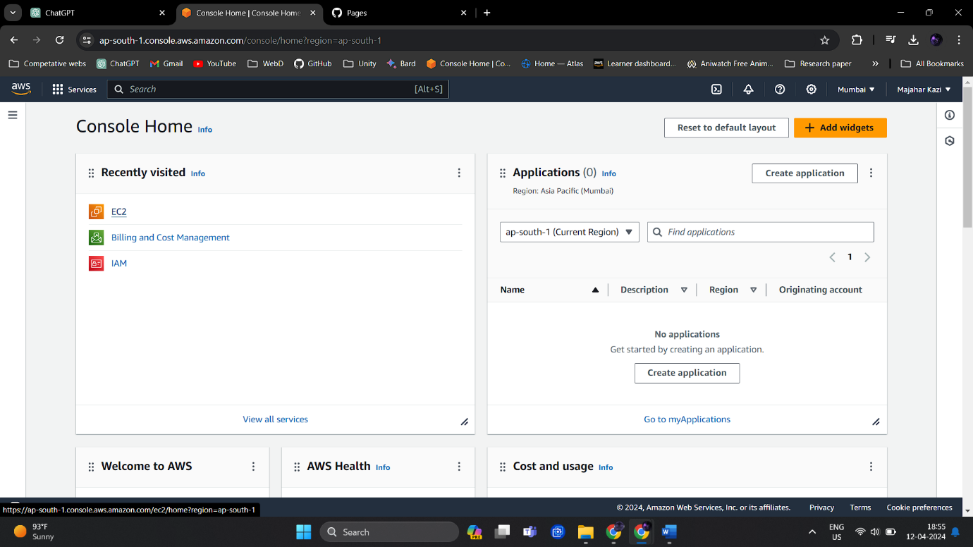

Then click onto launch instance.

Let the parameters for instance and machine be default.

Create a key pair for our instance, with .ppk file format.

Now all the arrangements for our instance are done, it’s time to launch our instance.

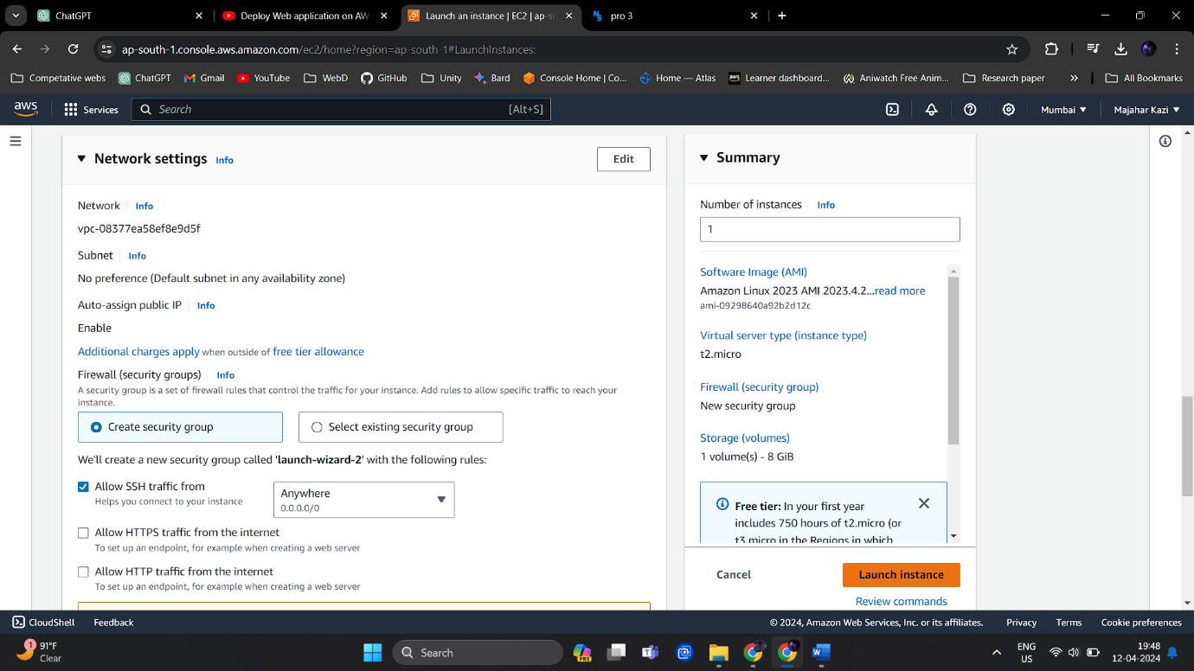

Our instance is created, now we need to connect to our instance by connect your instance option.

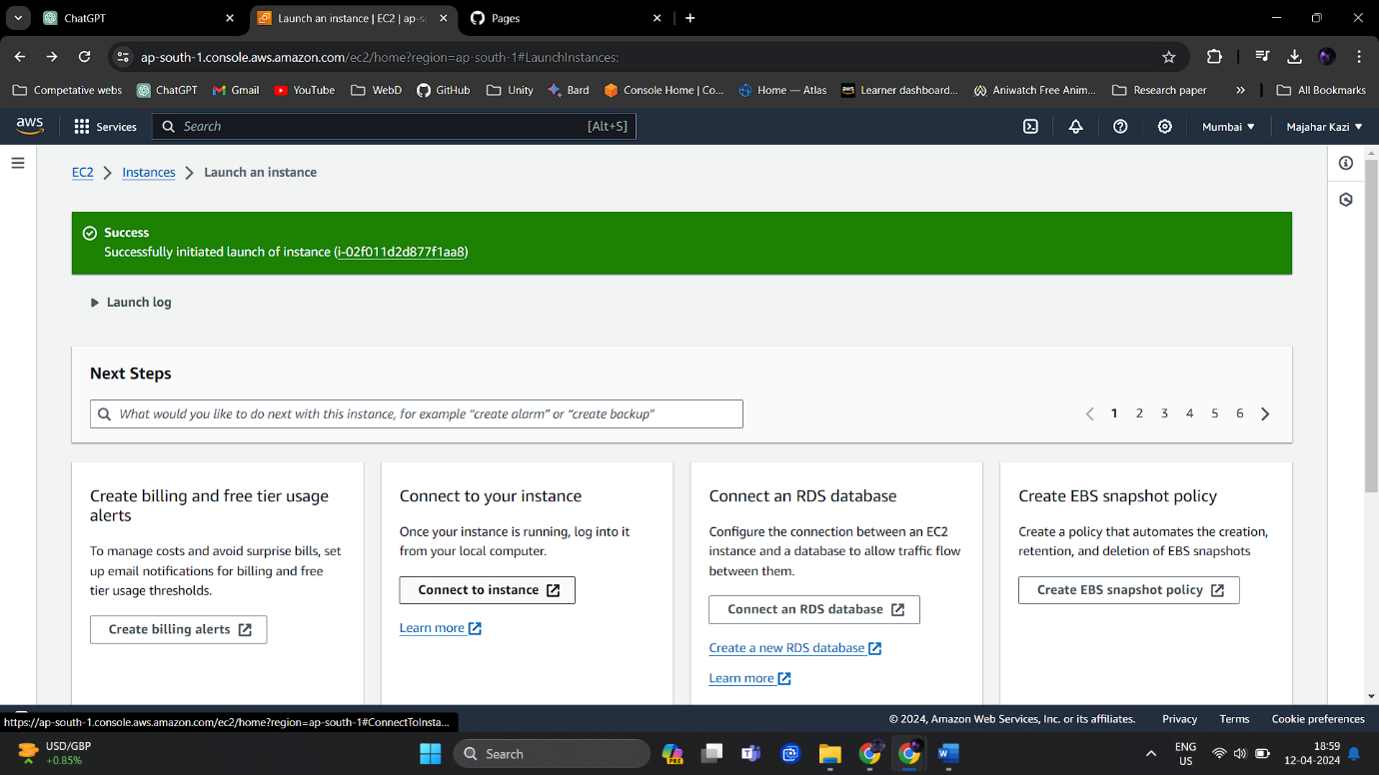

Press connect to connect with our virtual machine.

Now we are into our new vm, first we need to update it and install httpd in it to launch our website.

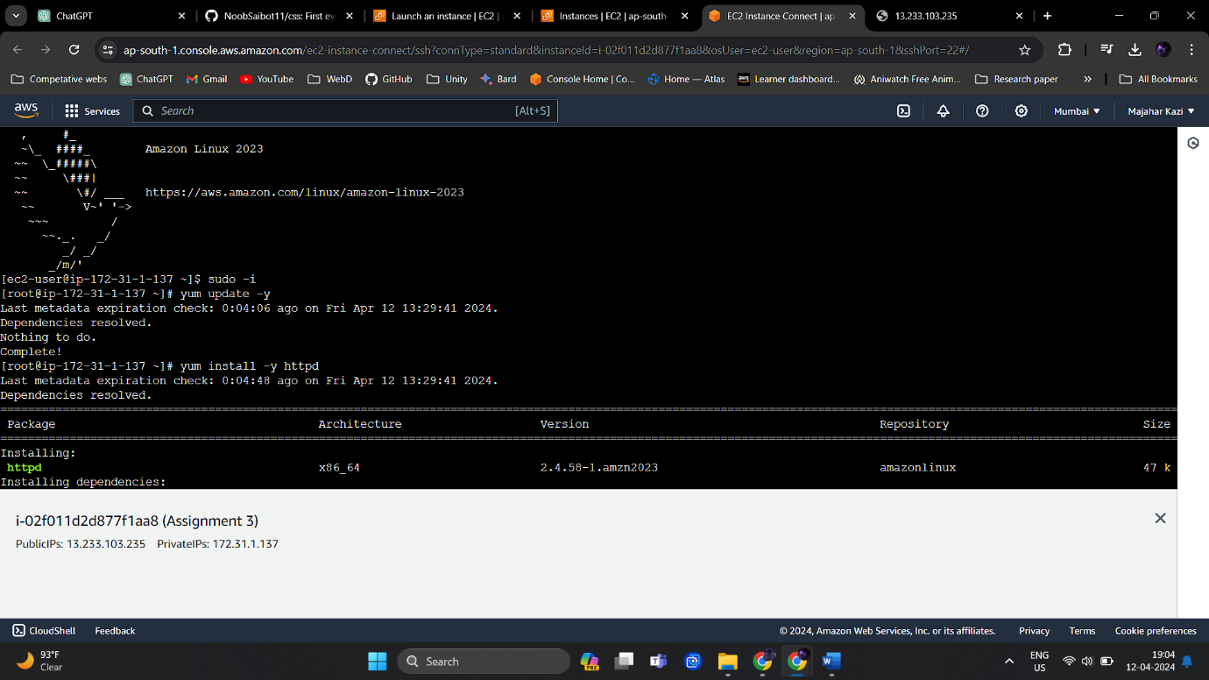

After installing httpd, we can see httpd services are disabled.

Now let us create a new directory in our vm for storing our website files.

Once we create new directory for our website files, we download those website files from our github.

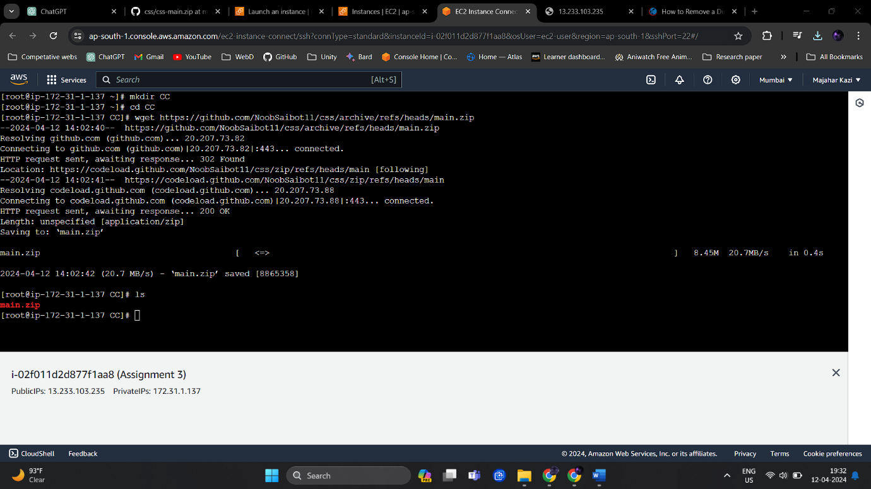

We have got the zip file for out files, now let’s unzip the main file.

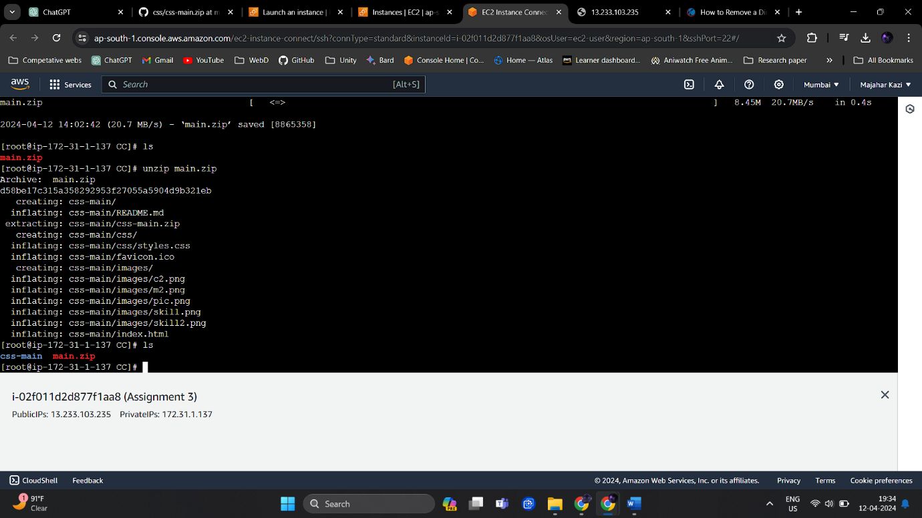

We can see all our web-files are extracted at our destination.

After that, we need to make changes in inbound group of our instance to allow traffic from http and https. Open security group of our instance from instances.

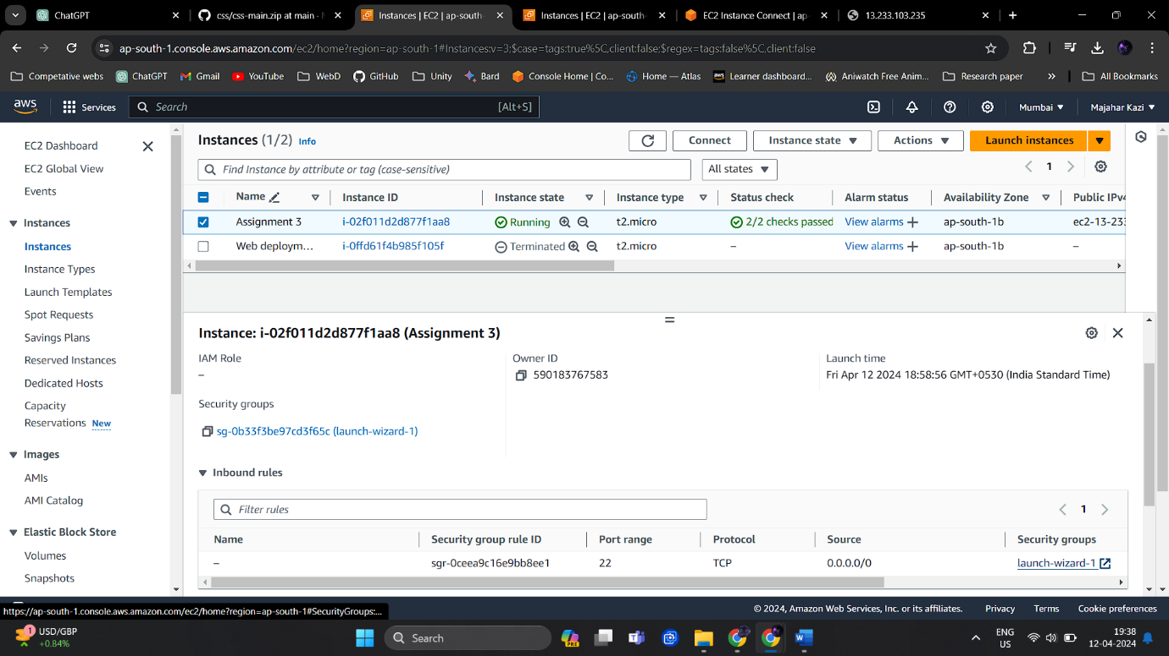

Select the launch wizard, our security group.

In the inbound rules select ‘Edit inbound rules’ and add rules as following.

Save these rules and close.

In our vm, select all the files from our web-files directory and move them into ‘/var/www/html/’.

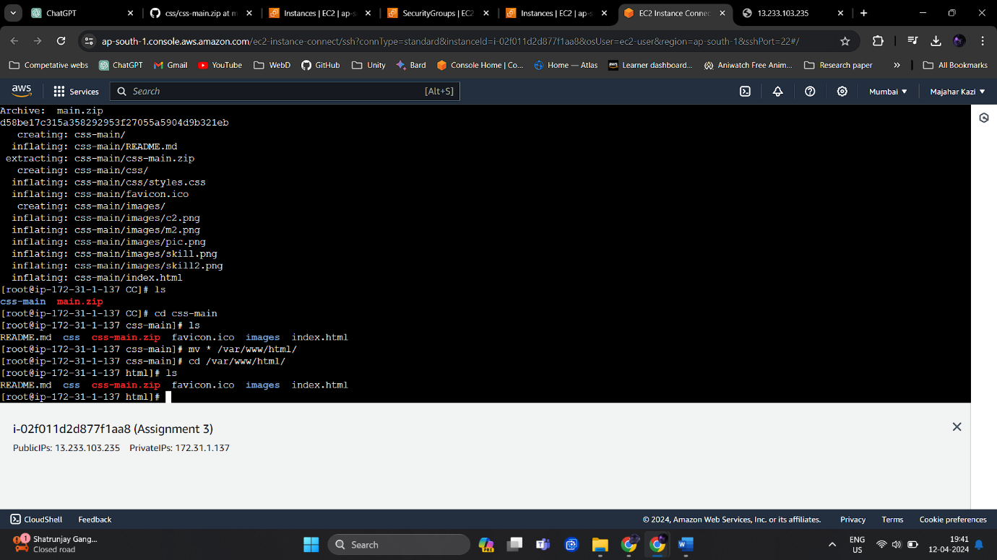

Now we need to enable httpd services for our vm.

Now our website is successfully launched with the help of AWS EC2 instance.

**Result:**

Author – Majahar Kazi

Friday 12 April 2024 08:26:34 PM IST